
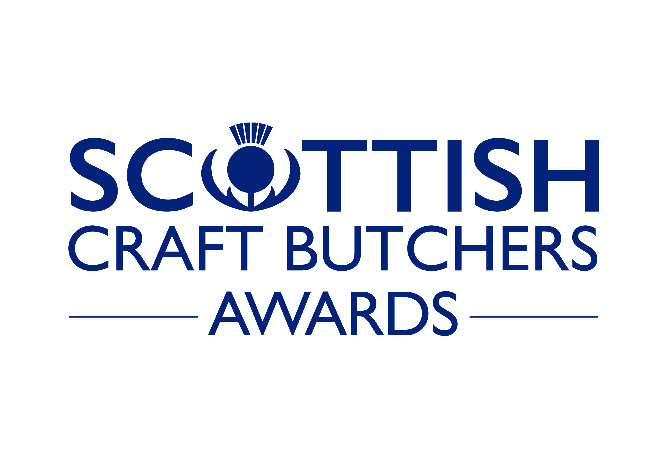


2024 BLACK PUDDING
SCOTTISH CHAMPIONSHIP
Sponsored by Scobie & Junor
____________________________________________________________
A COMPETITION TO FIND SCOTLAND'S BEST BLACK PUDDING
One Scottish Champion will be presented for the best product.
Five Regional Champions will be selected.

To be held on Thursday 2nd May 2024
Forth Valley College, Stirling Campus, Drip Road, Stirling, FK8 1SE
Tel: 01786 406000

PRIZES

FIRST £150 and the Championship Trophy
SECOND £100 and Reserve Champion Certificate
THIRD £50 and Third Place Certificate
Five regional winners will receive a Regional Champions certificate for 2024/25.

REGIONS FOR COMPETITION PURPOSES

SOUTH EAST: – Edinburgh Lothian and Borders
NORTH: – Aberdeenshire, Moray, Highlands, Western Isles
EAST: – Dundee, Angus and Fife, Forth Valley, Stirling, Perthshire and Kinross
WEST: – Argyll, Bute and Islay. Strathclyde excluding Ayrshire
SOUTH WEST: – Ayrshire and Arran, Dumfries & Galloway

CONDITIONS OF ENTRY

- Entries will only be accepted from members of Scottish Craft Butchers.
- Each entry must be made by the member or their staff.
- Each entry must be a typical example of the product as sold in the member’s premises.
- Only one Traditional Black Pudding can be entered per shop.
- Only the product detailed on the application form will be judged at the evaluation, care must therefore be taken to submit only that product which has been entered.
- Product Entry stickers will be sent to the entrant in advance to attach to their products.
If you do not receive your stickers by 26th^{th} April notify Scottish Craft Butchers.
- No changes can be made to entry or additional entries made after the closing date.
- Only products which require further cooking can be entered.
- Sufficient product must be provided to allow judging e.g. 6 slices black pudding.
- All entries should have a minimum two days shelf life.
- Nowhere should business names or identifiable brands be used on packs.
- The organiser cannot accept responsibility for loss, late arrival or damage in transit.
- Entries cannot be returned and will be disposed of after the event.
- The entries will be judged by a panel of judges. (chefs, foodies and consumers)
- The judges' decision is final and no correspondence can be entered into after the event.
- Entry is £18 per product and completed entry forms should be submitted to the Scottish Craft Butchers by Thursday 11th April 2024.
- Entries must be delivered to Service Entrance, Forth Valley College, Stirling Campus, Drip Road, Stirling, FK8 1SE Tel: 01786 406000 on Thursday 2nd May between 9.30am and 4.00pm.
- Results will be announced at the regional meetings the week commencing 20th May 2024 on Facebook and on www.craftbutchers.co.uk
- Recipes for Products will remain the exclusive property of the entrant.
- Awards must be described with the prefix 2024/25 for ongoing promotional purposes.
BLACK PUDDING JUDGING FORM
(each criteria marked out of 10 = maximum score 70)

ENTRY NUMBER
RAW
Uncooked Texture and Appearance
General Appeal
COOKED
Texture and Appearance
Shrinkage
Texture/Binding
Smell
Taste & Flavour
TOTAL

Sponsored by

BLACK PUDDING JUDGING FORM

ENTRY FORM

Please complete this form in BLOCK CAPITALS and forward to
Scottish Craft Butchers, 8 Needless Road, Perth, PH2 0JW

Entries cannot be accepted after 11th April 2024
Name:
Address
Postcode

I agree to the rules of the awards | (Signed)
Please print name below signature | (Print)

I enclose cheque for £18 or BACS payments can be made to Scottish Craft Butchers
Sort Code: 83-47-00 Account No. 10023331
Entries close 11th April 2024 and are ONLY accepted when accompanied by payment.

Name of Product | ENTRY FEE
BLACK PUDDING | £18
If you wish to take advantage of a collection point, deliver there by 11.00am on
Thursday 2nd May and indicate below which point you will drop off at.

Shaws Fine Meats, 12 Market Place, Lauder. Tel: 01578 722306
Gordon McWilliam (Aberdeen) Ltd, 37 St Clement St,
Aberdeen, AB11 5FU Tel: 01224 211174
James Chapman (Butchers) Ltd. Glasgow Road, Wishaw. Tel: 01698 372028
John M Munro, Queensgate, Inverness. Tel: 01463 233066
Scottish Craft Butchers, 8 Needless Road, Perth, PH2 0JW. Tel: 01738 637472

