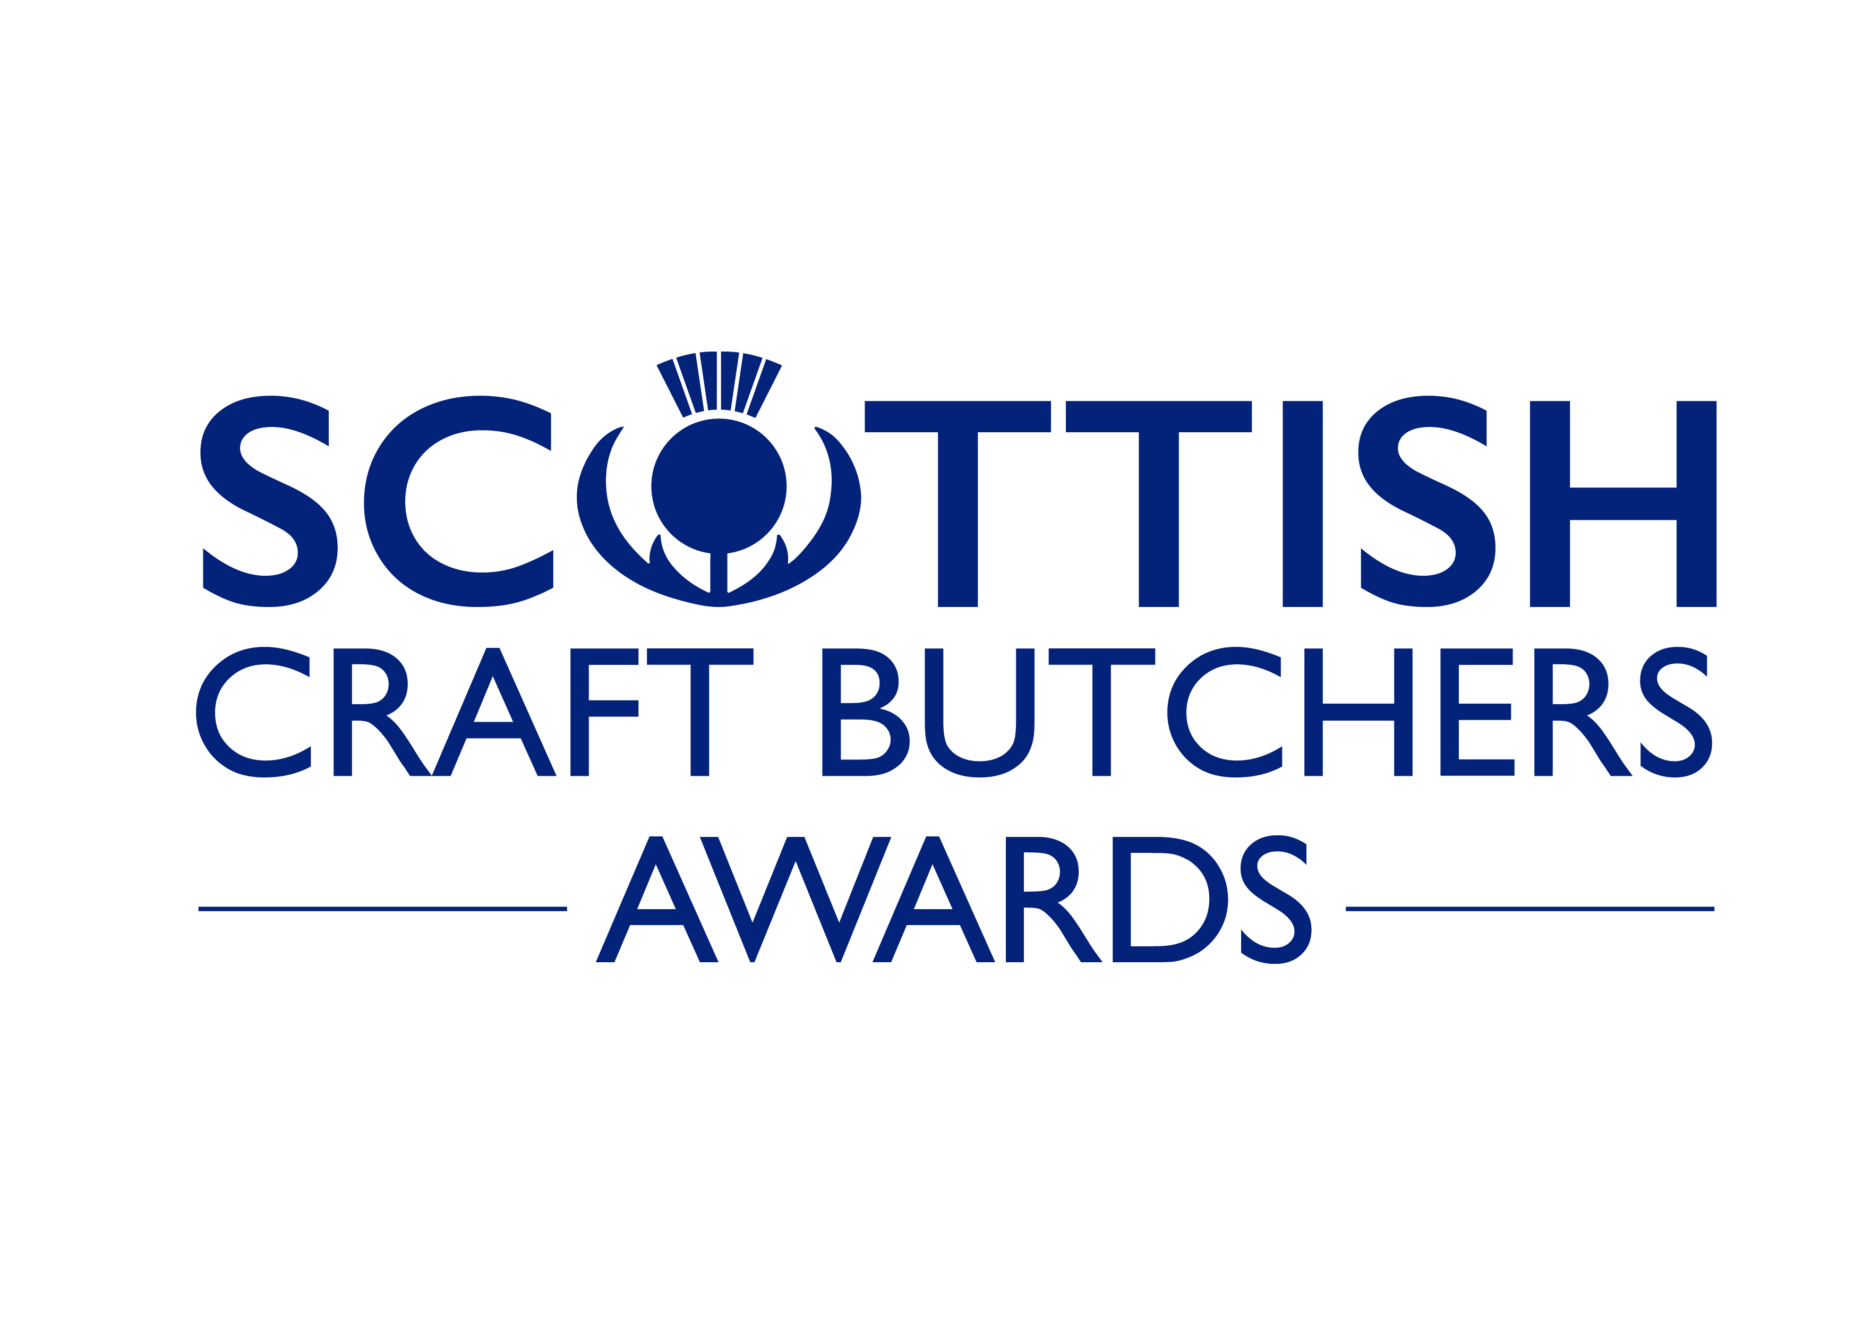

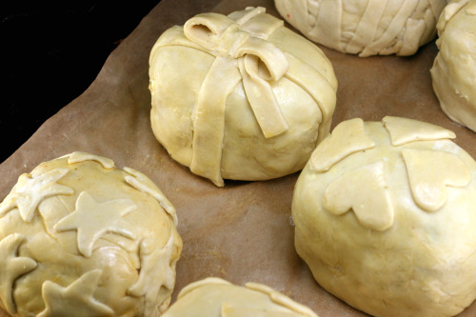
HOME CURED BACON
PRODUCT EVALUATION 2024
Sponsored by Scotweigh
____________________________________________________________
A COMPETITION TO FIND
SCOTLAND'S BEST HOME CURED BACON PRODUCTS
One Diamond Award will be presented for the best product.
Gold and Silver Awards to all those worthy of such recognition.

To be held on Thursday 2nd May 2024
Forth Valley College, Stirling Campus, Drip Road, Stirling, FK8 1SE
Tel: 01786 406000

CONDITIONS OF ENTRY

- Entries will only be accepted from members of Scottish Craft Butchers.
- Entry must only use bacon that has been home cured on the retailers premises.
- Each entry must be made by the retailer or their staff.
- Products entered must have home cured bacon as the predominant part of the overall product.
- Maximum 4 entries per shop.
- Entries are for home cured bacon products. Think, Treacle Smoked Bacon, Dry Cured Bacon, , Bacon Burger, Bacon Chop Sweetcure, Sugar Pit Gammon Steak.
- Only the product detailed on the application form will be judged at the evaluation, care must therefore be taken to submit only that product which has been entered along with the cooking instructions.
- Product Entry stickers will be sent to the entrant in advance to attach to their products.
If you do not receive your stickers by Friday 26th April notify Scottish Craft Butchers.
- No changes can be made to entry or additional entries made after the closing date.
- The product must be presented in a state that requires further cooking.
- Sufficient product must be provided to allow judging e.g Minimum 6 rashers of bacon. We need enough product for 6 people to taste, two portions to be cooked by the chefs at the college cooked and one left uncooked to compare.
- All entries to have minimum two-day shelf life.
- Nowhere should business names or identifiable brands be used on packs.
- The organiser cannot accept responsibility for loss, late arrival or damage in transit.
- The entries will be judged by a panel of judges. (chefs, foodies and consumers)
- The judges' decision is final, and no correspondence can be entered into after the event.
- Entry is £18 per product and completed entry forms should be submitted to the Scottish Craft Butchers by Thursday 11th April 2024.
- Entries must be delivered to Service Entrance, Forth Valley College, Stirling Campus, Drip Road, Stirling, FK8 1SE Tel: 01786 406000 on Thursday 2nd May 2024 between 9.30am and 4.00pm.
- Results will be announced at the Regional Meetings on 20th 21st 22nd 23rd May 2024 and on www.craftbutchers.co.uk. Please book your place to attend the meetings
- Recipes for Diamond Award Products will remain the exclusive property of the winners.
- For future promotion, awards must be described with the prefix 2024.

Product Evaluation Judging Form
Entry Number: Product Name:
Uncooked Appearance |  |  | Product Composition |  | Cooked Appearance |  |  | Smell |  | Texture |  | Taste |  | Overall Appeal |  | T
Unacceptable | 1 |  | Unacceptable | 1 | Extremely raw, burnt | 1 |  | Extremely Unpleasant | 1 | Extremely tough dry | 1 | None /extremely unpleasant | 1 | Unacceptable | 1 | O
Very poor | 2 |  | Extremely poor | 2 | Very  raw, burnt | 2 |  | Very unpleasant | 2 | Very  tough dry | 2 | Very unpleasant /bland | 2 | Extremely poor | 2 | T
Poor | 3 |  | Very Poor | 3 | Raw, burnt | 3 |  | Unpleasant | 3 | Tough, dry | 3 | Slightly unpleasant or overpowering | 3 | Very Poor | 3 | A
Messy | 4 |  | Poor | 4 | Slightly raw, burnt | 4 |  | Poor | 4 | Chewy | 4 | Palatable | 4 | Poor | 4 | L
Acceptable | 5 |  | Acceptable | 5 | Acceptable | 5 |  | Appropriate | 5 | Acceptable | 5 | Acceptable | 5 | Acceptable | 5
Good | 6 |  | Good | 6 | Good | 6 |  | Good | 6 | Tender, moist | 6 | Good | 6 | Good | 6 | S
Very good | 7 |  | Very good | 7 | Very good | 7 |  | Very pleasant | 7 | Very  tender / moist | 7 | Very Flavoursome | 7 | Very good | 7 | C
Extremely good | 8 |  | Extremely good | 8 | Extremely good | 8 |  | Extremely pleasant | 8 | Extremely tender /moist | 8 | Extremely Flavoursome | 8 | Extremely good | 8 | O
Excellent | 9 |  | Excellent | 9 | Excellent | 9 |  | Exceptionally pleasant | 9 | Excellent | 9 | Excellent | 9 | Excellent | 9 | R
Superb | 10 |  | Superb | 10 | Superb | 10 |  | Superb | 10 | Superb | 10 | Superb | 10 | Superb | 10 | E
Add scores |  |  | + |  | + |  |  | + |  | + |  | + |  | +
Judge’s Comments
 |  | (circle number which best represents products attributes) SCORING: 70-60 = Gold 59-50= Silver

Sponsored by Scotweigh

ENTRY FORM

Please complete this form in BLOCK CAPITALS and forward to
Product Evaluation, Scottish Craft Butchers, 8 Needless Road, Perth, PH2 0JW

Entries cannot be accepted after 11th April 2024
Name:
Address
Postcode

I agree to the rules of the awards | (Signed)
Please print name below signature | (Print)

I enclose cheque for £______for ______entries @£18 each.
or BACS payments can be made to Scottish Craft Butchers
Sort Code: 83-47-00 Account No. 10023331
Entries close 11th April 2024 and are ONLY accepted when accompanied by payment.

Name of Product | Description & Cooking Instructions  (keep this brief, a full list of ingredients is not required)
 | e.g.Bacon Chop Honey cured, Grill or fry for 3 mins each side.
If you wish to take advantage of a collection point, deliver there by 11.00am on
Thursday 2nd May and indicate below which point you will drop off at.
(The transportation from the collection point leaves at 11 am and cannot be delayed.)
Shaws Fine Meats, 12 Market Place, Lauder. Tel: 01578 722306
Gordon McWilliam (Aberdeen) Ltd, 37 St Clement St,
Aberdeen, AB11 5FU Tel: 01224 211174
James Chapman (Butchers) Ltd. Glasgow Road, Wishaw. Tel: 01698 372028
John M Munro, Queensgate, Inverness. Tel: 01463 233066
Scottish Craft Butchers, 8 Needless Road, Perth, PH2 0JW. Tel: 01738 637472

